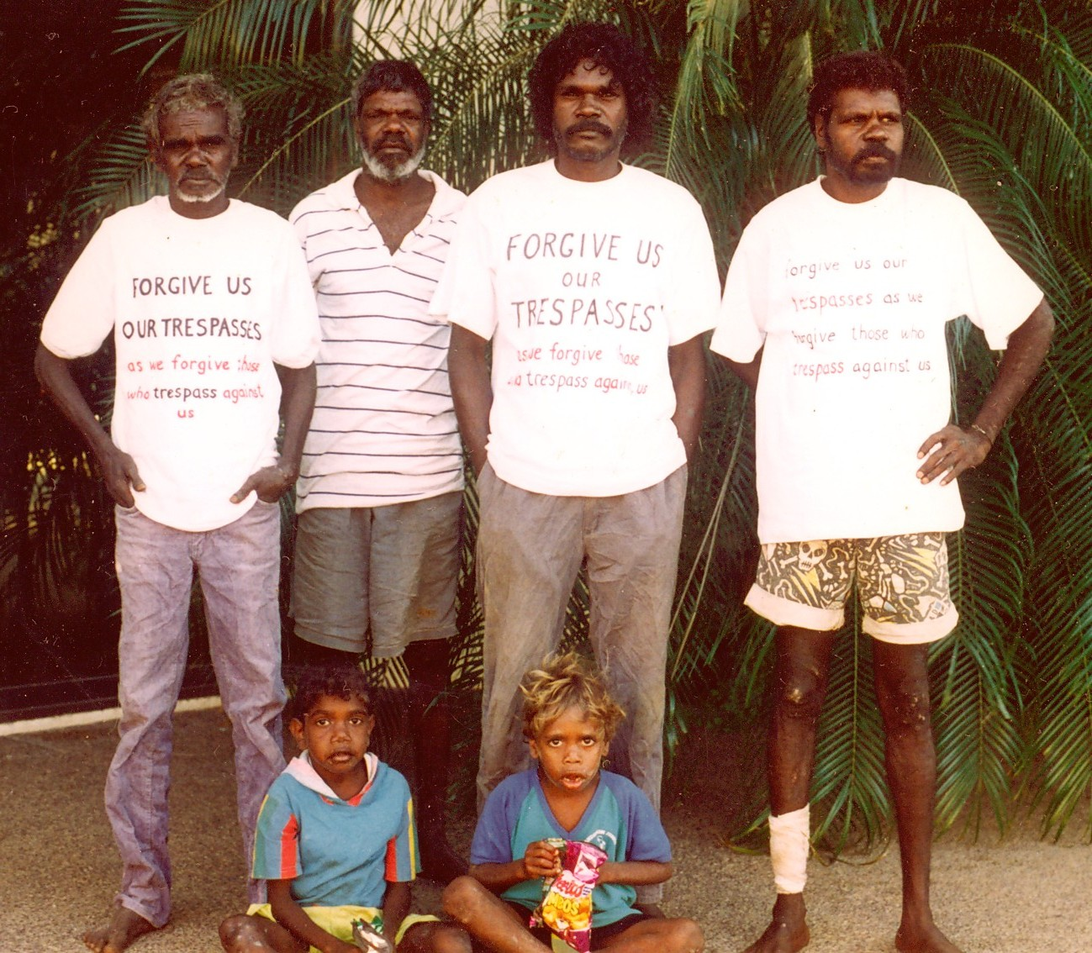

Four men attended the Magistrate’s Court wearing a message on their T shirts, ‘Forgive us our trespasses as we forgive those who trespass against us.’

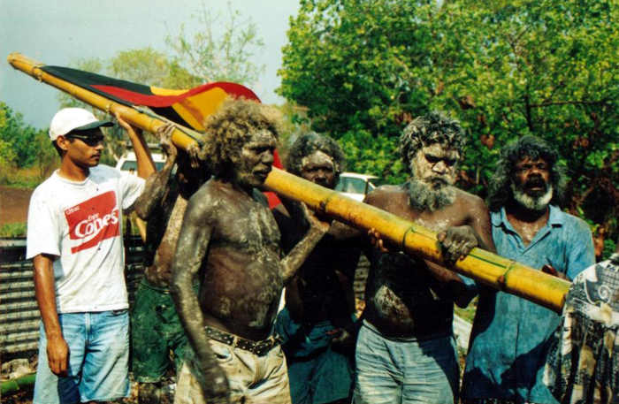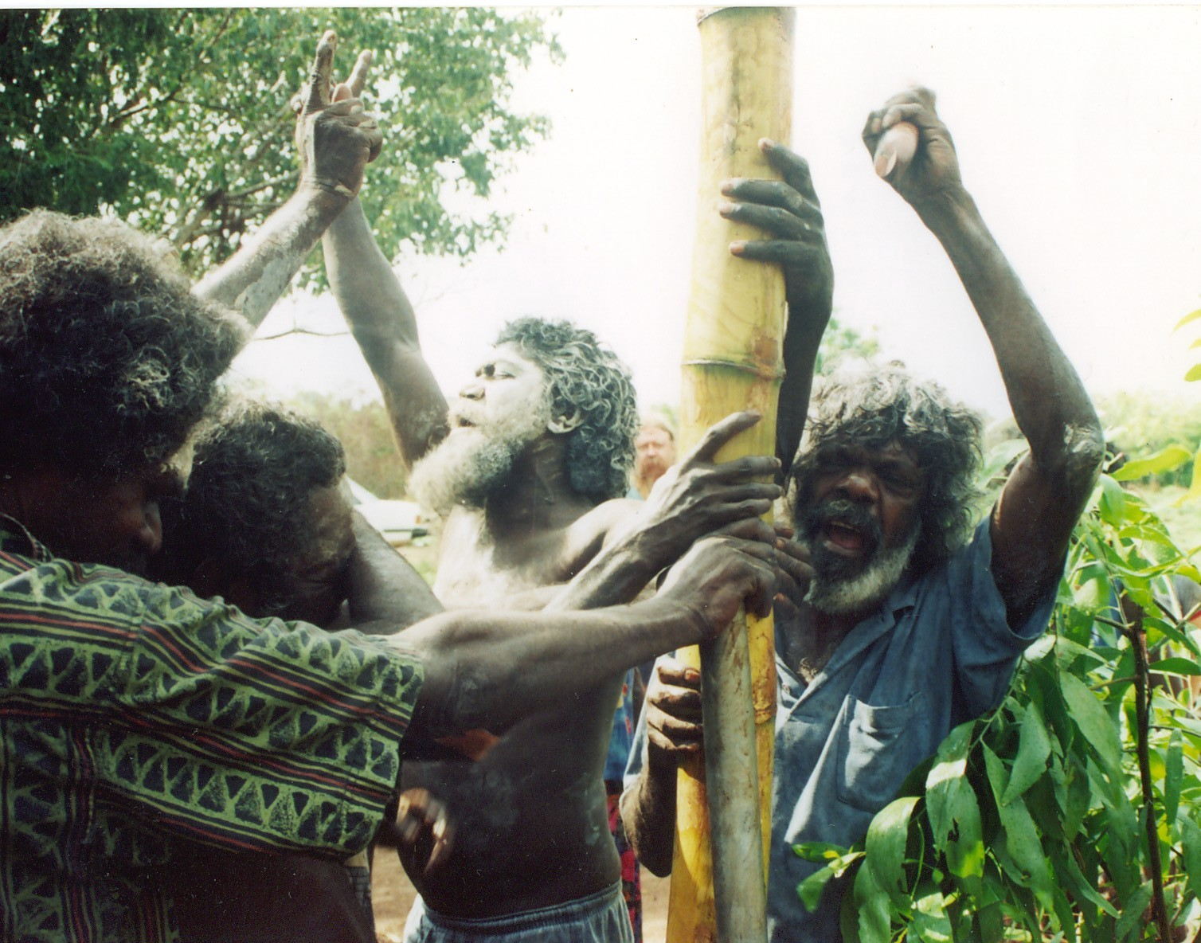

After a year, a new Aboriginal flag was raised at Fish Camp in memory of Gojok. As the flag pole was put in the ground, an old Macassan song was sung.

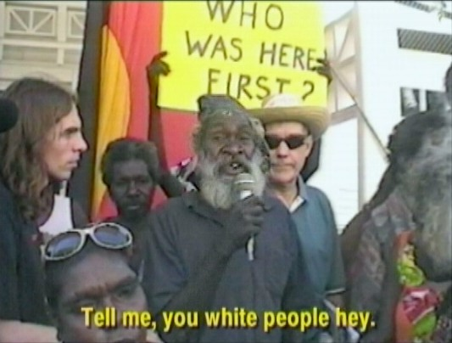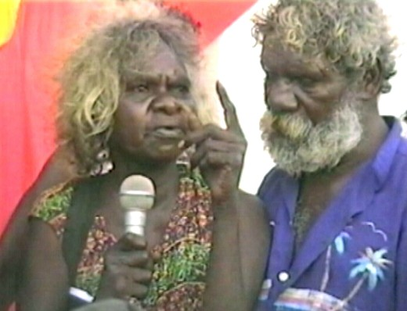

On August 3rd, 2001, ‘long grass people’ from all around Darwin marched back to Parliament House to protest against new laws being made against homeless people.

